**Performance Monitoring Basics**

**JVM---Java Virtual Machine**

**JDK----Java Development Kit**

it is used to develop and run the java Application

* Java API--it is libraries used inside the Program--to make the java Application--.java source Code

*Java Compiler--compiling source Code ---🡪ByteCode( .class)

* JVM-Java Virtual Machine--Run the Java Application-- ByteCode---->MachineCode

**JRE-Java Runtime Environment**

it is used only to Run already developed Runnable Java Application

*JVM---Java Virtual Machine

JVM--Occupy Some Amount RAm memory

it divides that memory into Three Regions

**1.Stack(Used to Store the Local Objects of the java Application)**

**2.Java Heap(Used to Store the Global Objects of the java Application)**

**3.NativeIO**---Some Amount of memory occupied to run the JVM

**Garbage Collector**--- It is an Automatic Process Runs inside the JVM

used for Clearing the Memory occupied by the **Unused Objects**

**JVM Memory Spec:**

**Min Heap Size-Xms**

**Max Heap Size-Xmx-**

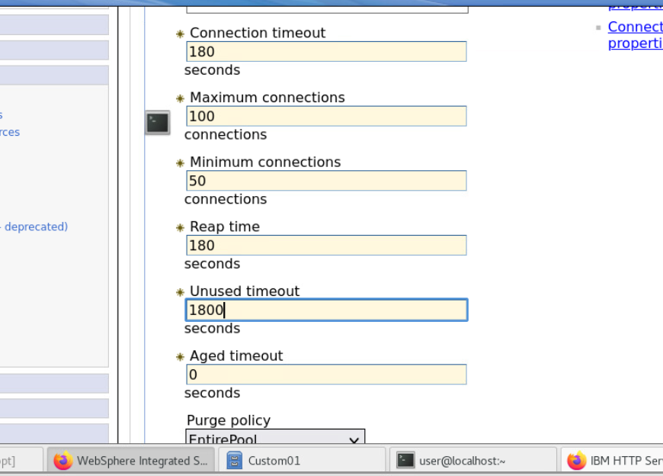

**LifeCycle of Transaction**

1.begin(start)

2.commit

3.rolledback

**Threads-**---Process inside a Process or Piece of Execution inside the Program

------------------------

Monitor the Performance of WEbSphere Server

IBM**-- Tivoli Perfomance Viewer**--used to view the Performance of the WAS

JDBC Connection Pool

JVM Memory

Servlet Session(Instance count)

CPU Usage

Servlet Processing Time

Threads

Transaction Manager Report

Ways of a Monitoring a Websphere

1.Tivoli performance viewer

2.WSADMIN—Command line Monitor

3.Third Party Monitoring tool

WillyIntroscope-CA

JProbe—Quest

Jprofiler—EJ Technologies

BMC Patrol—Quest

Foglight---Quest

Nelson---HP